Day 22: 13-11-2025:

Security :
Authentication and Authorization:
Authentication mainly use to access the any resource with their credentials details like email Id and password.
Authorization base upon the role allow to access the specific resources. Like Role admin, manager, customer etc
Core Java security classes.
JEE technologies also security classes provided by Java people or server etc
Database level security
Spring framework we have lot of security classes which we were doing configuration using xml.
Spring boot also provided security starter.

Spring boot provided security starter. Once you added security starter automatically default security features enable for your project.

In spring boot we can create normal controller as well as rest controller
We can access any view page directly is jsp or thymeleaf.
We can access any end point directly.
Once you added spring boot security if you are planning to access any view page or end point spring boot security open default login page it will ask you login details.
By default user name is and password auto_generated. You need to take the help of auto generated password to access those resources

Creating simple spring boot security project
Starter Web (Controller or Rest controller )
Starter security

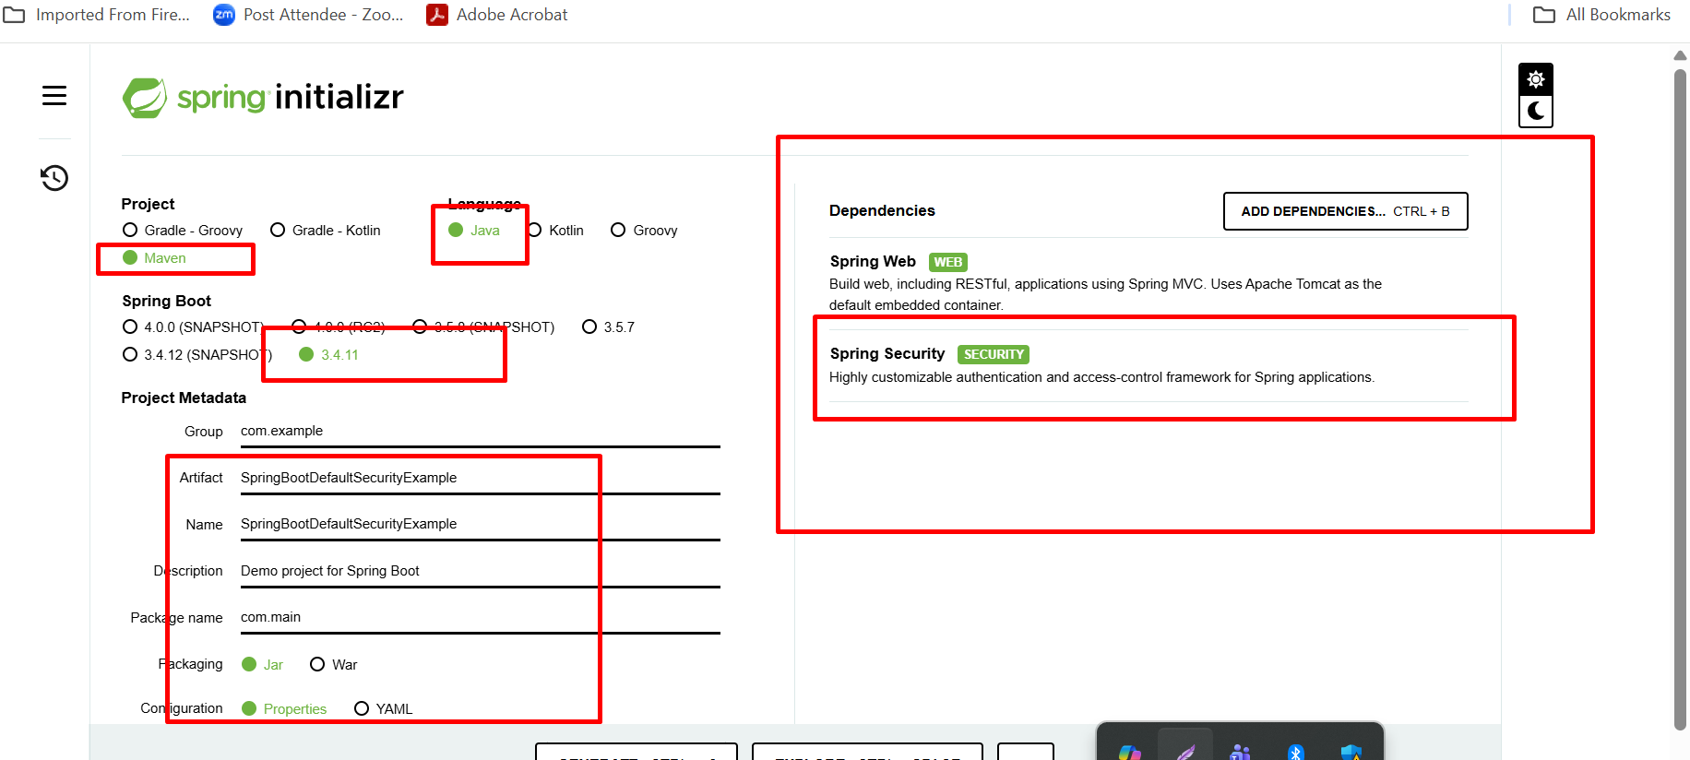

Once you hit the any end point URL. Spring boot security provide default login page and you need provide username as user and password random password (display on console).
After login you can access any resources
For logout

http://localhost:8080/logout

if you want custom username and password you can provide using 2 ways.
- application.properties or application.yml
- using java class with @Configuration class and @EnableWebSecurity

Spring boot security API
- UserDetailsService : Interface
- UseDetails
- User
These 3 API help us to keep the track about spring user security features.

Spring boot provided pre defined api BCryptPasswordEncoder
Which help to convert password in hashing format.

Authentication
Authorization
Base upon the role we want to access specific end points. Role base authentication.
Old version of spring boot before 2.7 or till 2.x version Spring boot provided one the pre defined class ie WebSecurityConfigureAdapater.
This class hold all url path as well as access those url base upon role.
But new version SecurityFilter, this class defined how security Is applied for each incoming http request. Which hold authentication details and authorization with roles and their url.

